HOW TO REGISTER A NEW PROGRAM on YOUTHPROGRAMS.SYR.EDU

Visit youthprograms.syr.edu to register the program. Log in with your NetID credentials, without the “@syr.edu” portion of your login. This is what you will see when you visit youthprograms.syr.edu prior to log-in:
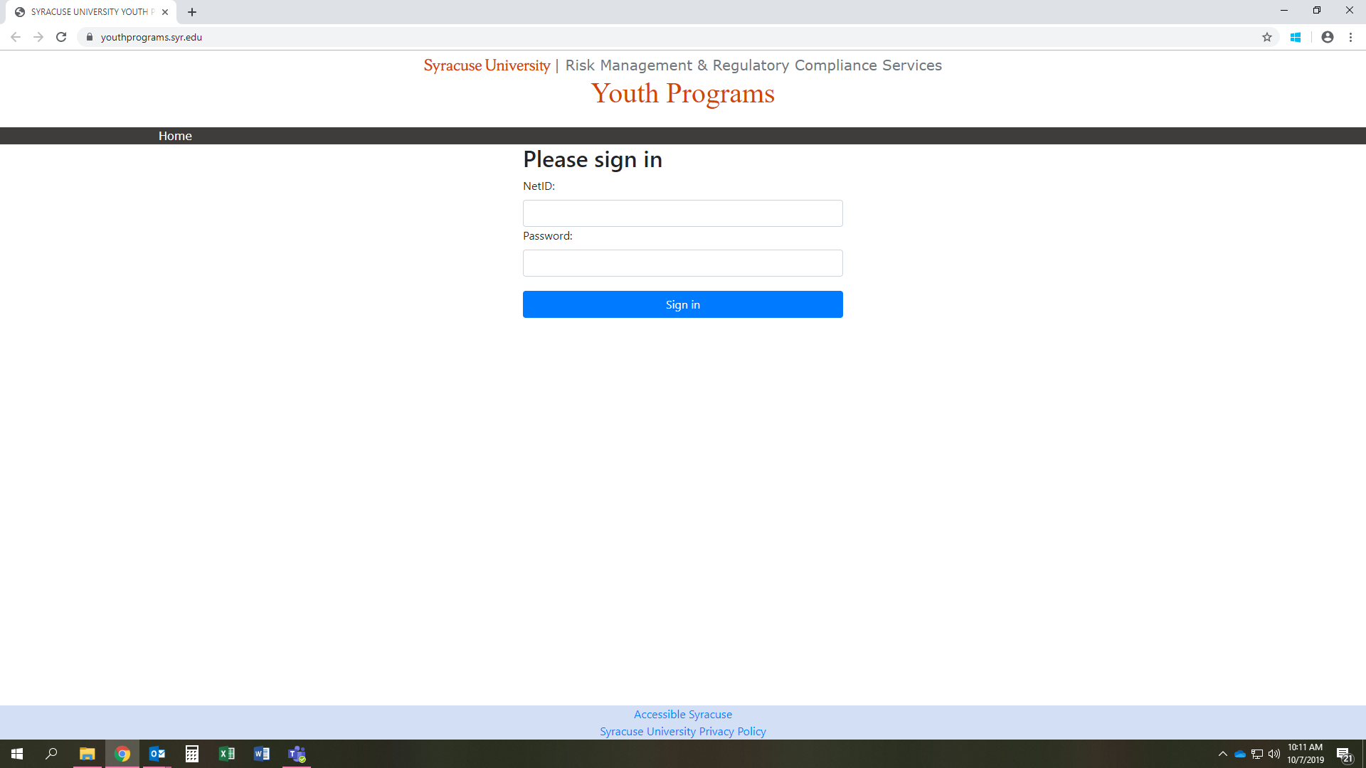

Once you log in, this is the screen you will see if you have never logged into this site before:
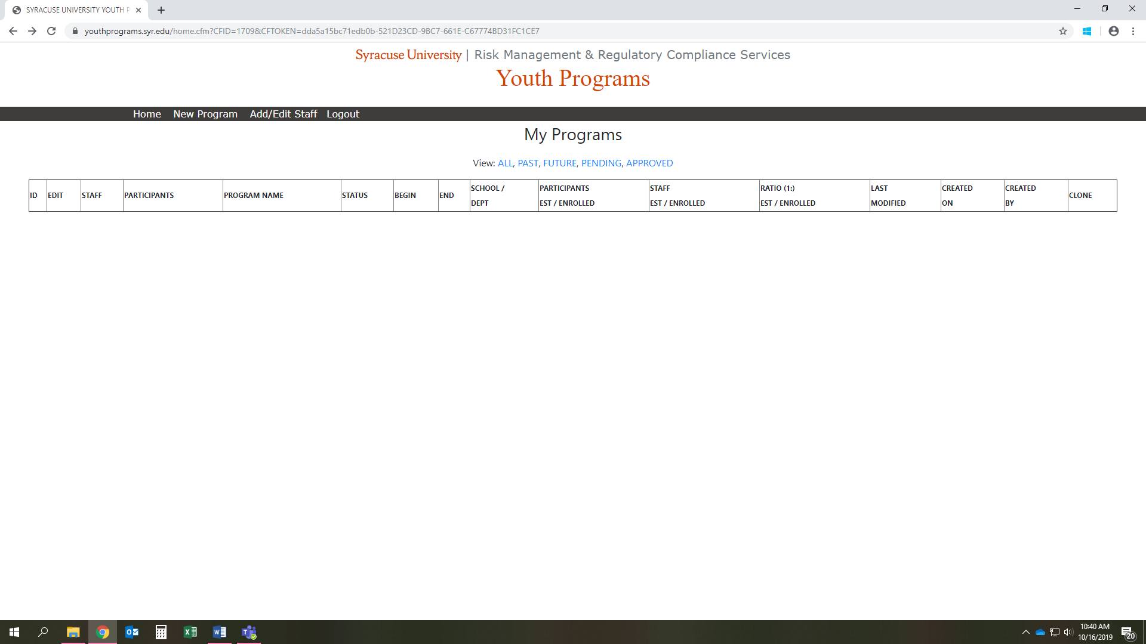

Click on “New Program” in the black tool bar to create a new program registration. The next image is what it looks like prior to submitting any information for the new program.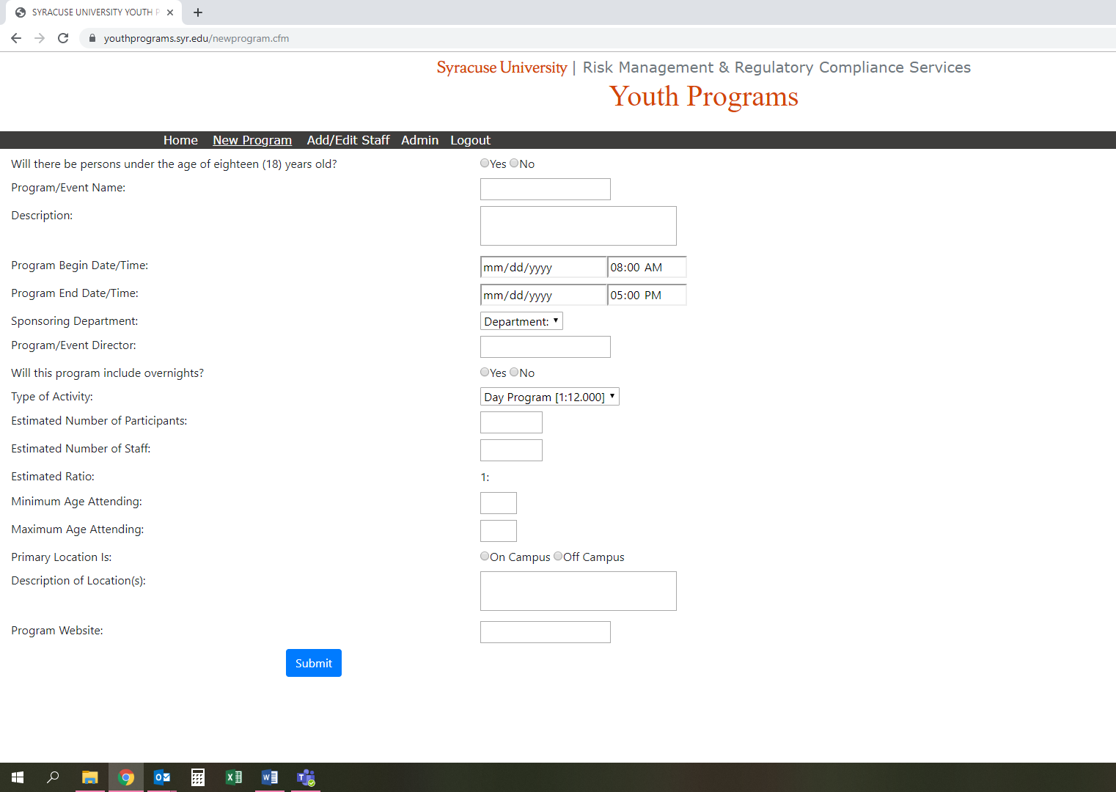
Once you enter the information, click submit at the bottom of the page.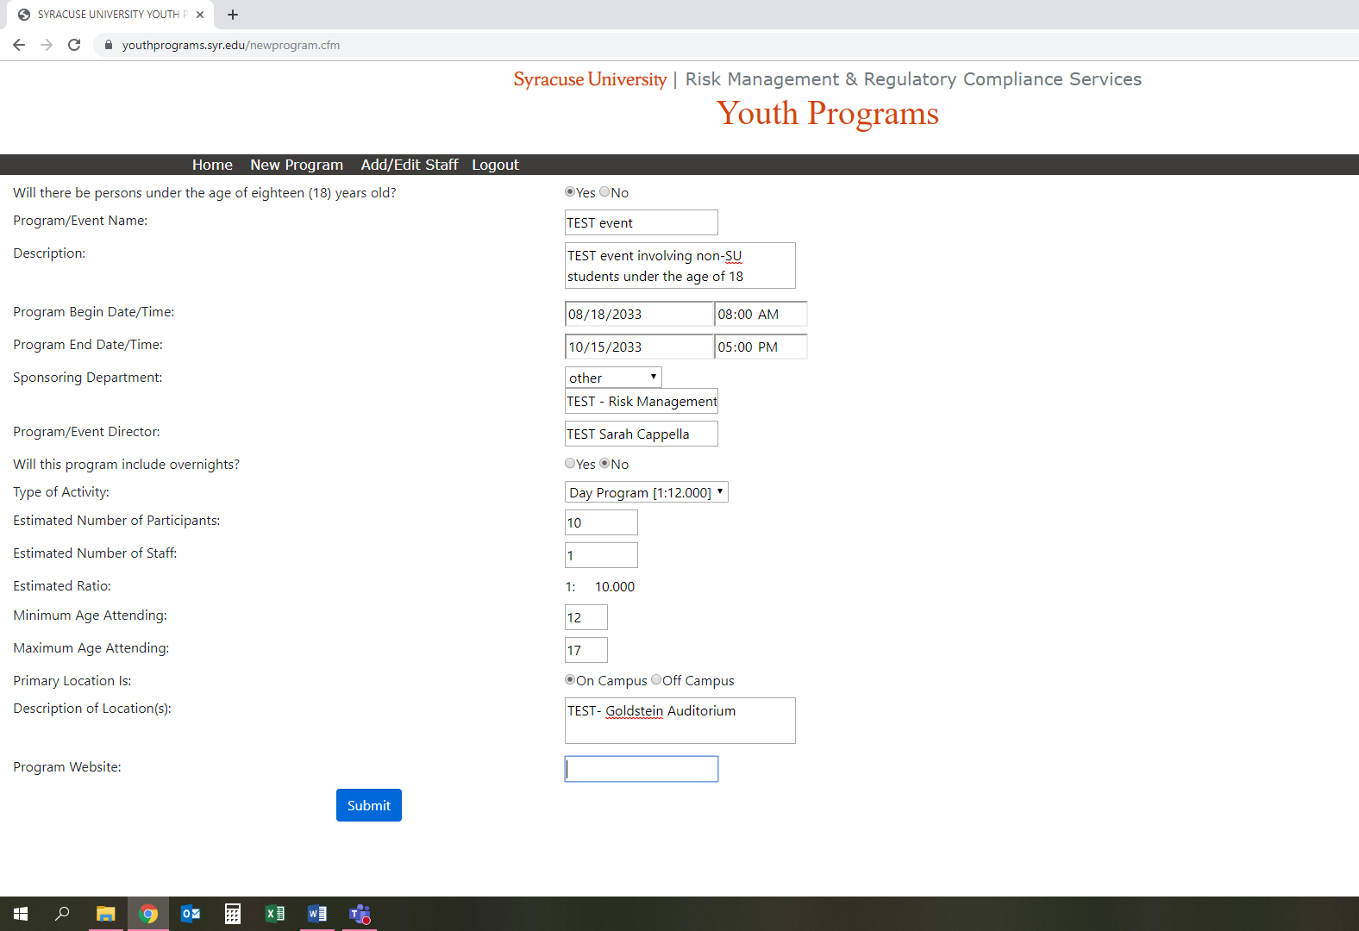

When you click submit, and the program is registered successfully, you will see the image below: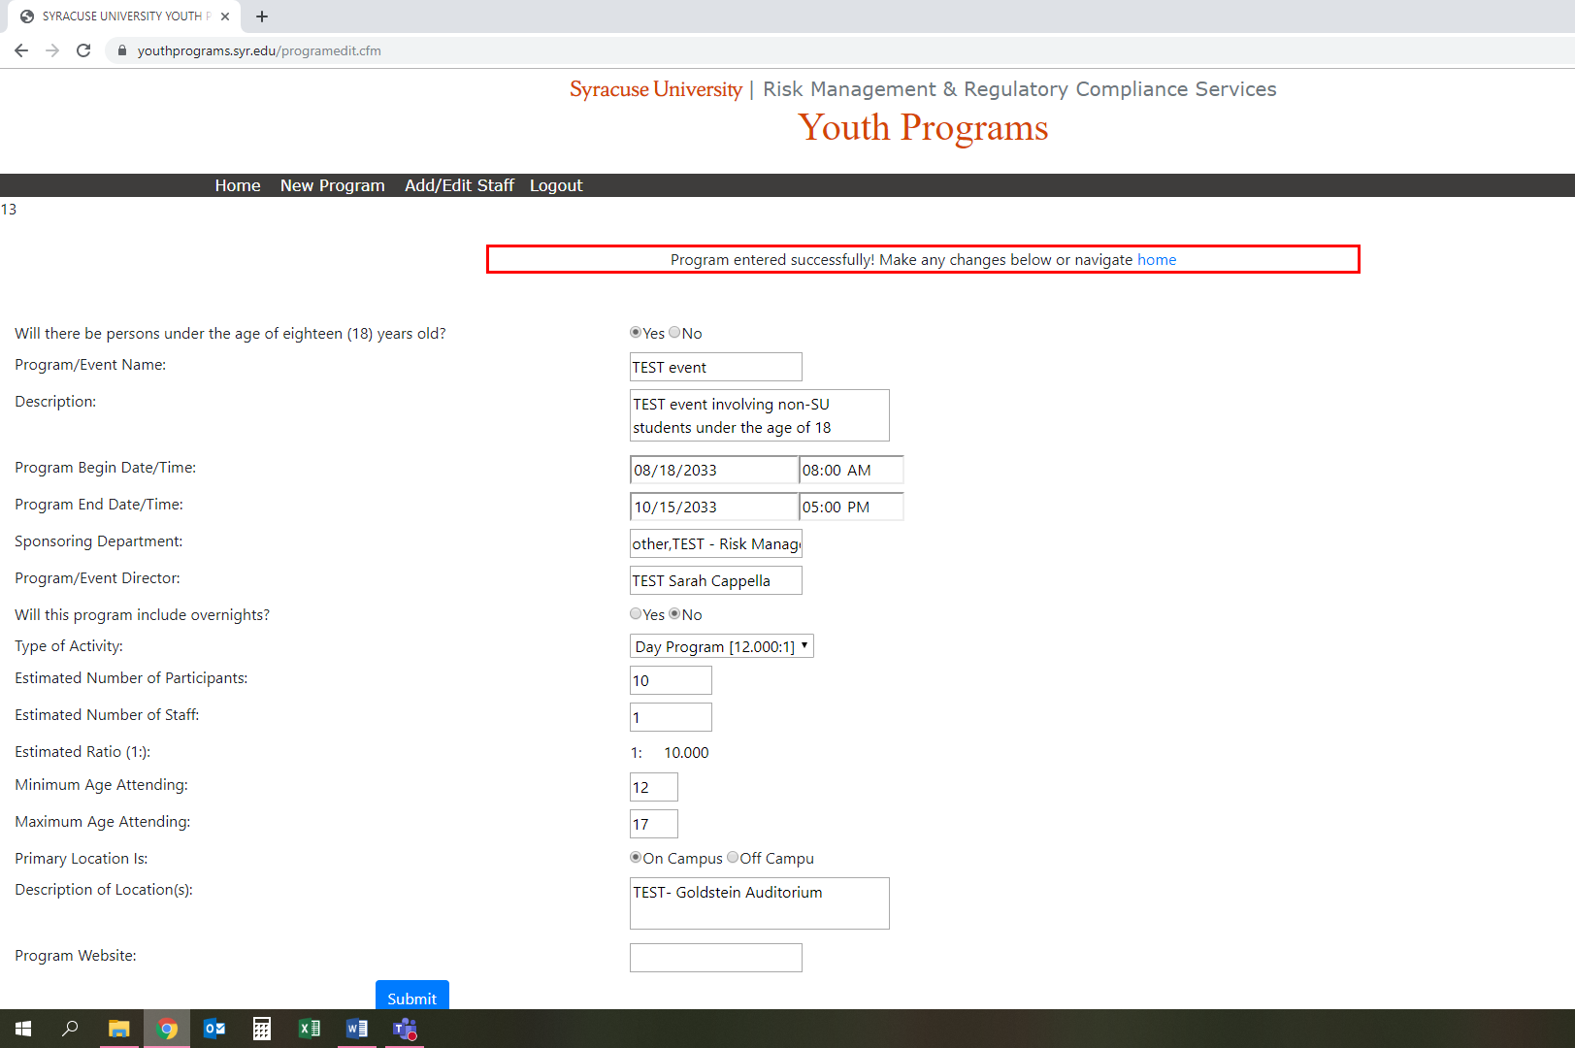

To double check that your submission was successful, or to edit the program, click on ‘Home’ in the black toolbar and you should see the program in the main body of the website:
